**Github Link (code):** [**https://github.com/aishwarya03032023/Assignment-4**](https://github.com/aishwarya03032023/Assignment-4)

**Singleton Design Pattern**

## Test Case 1: testGetInstance()

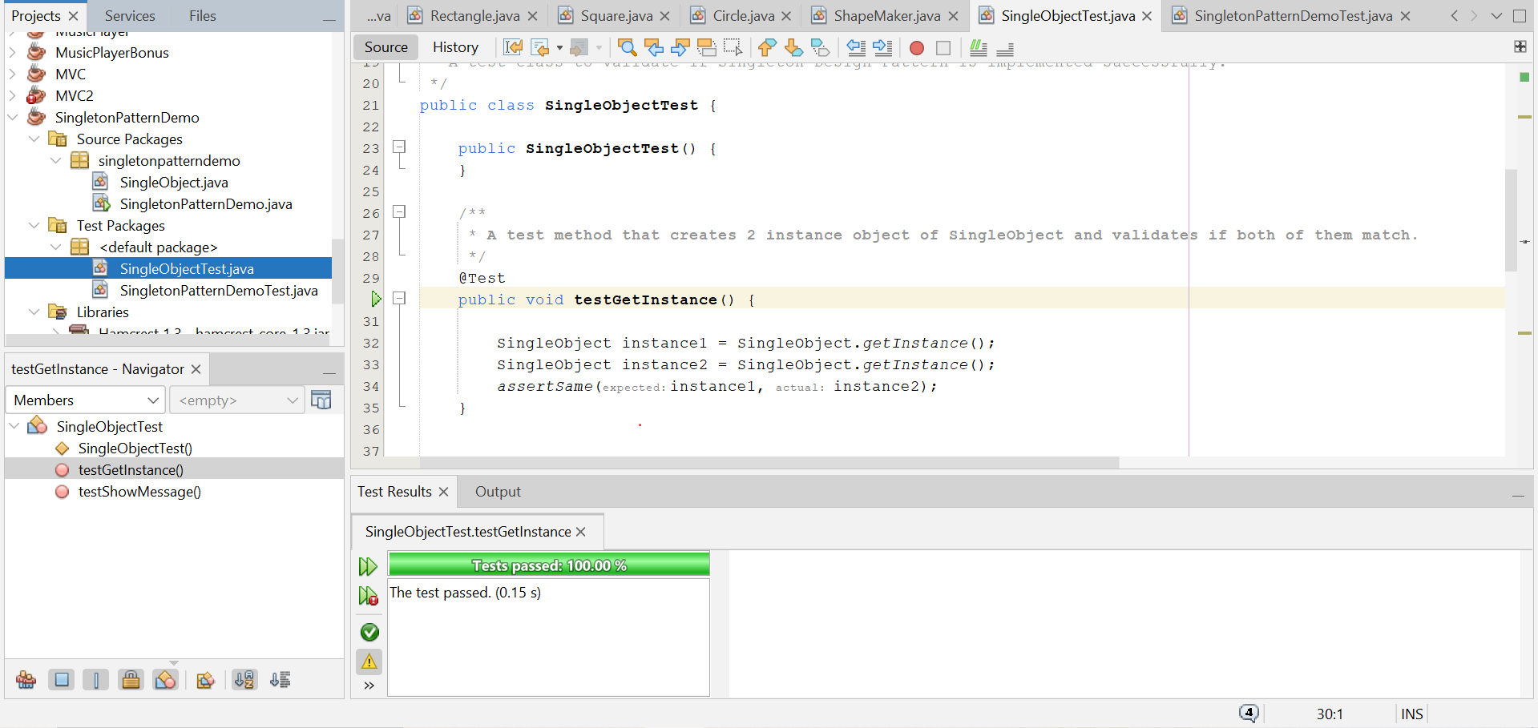

## Test Case 2: testShowMessage()

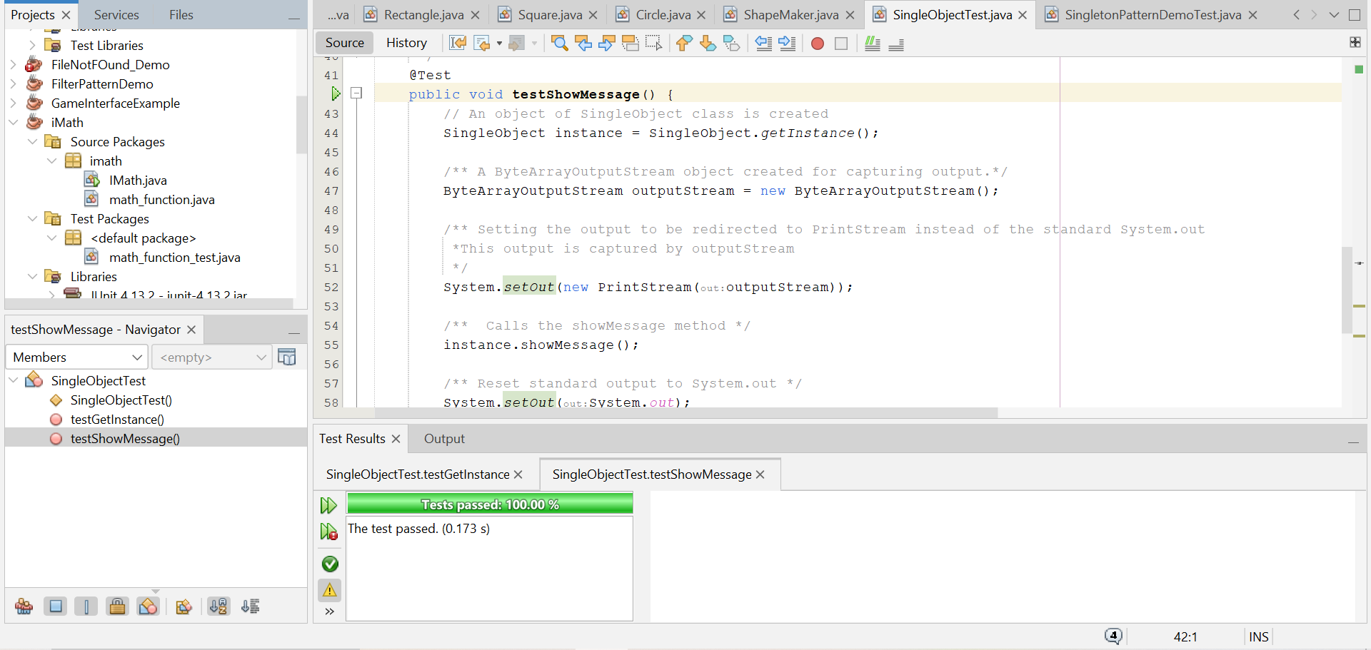

**Façade Design Pattern**

## Test Case 1:

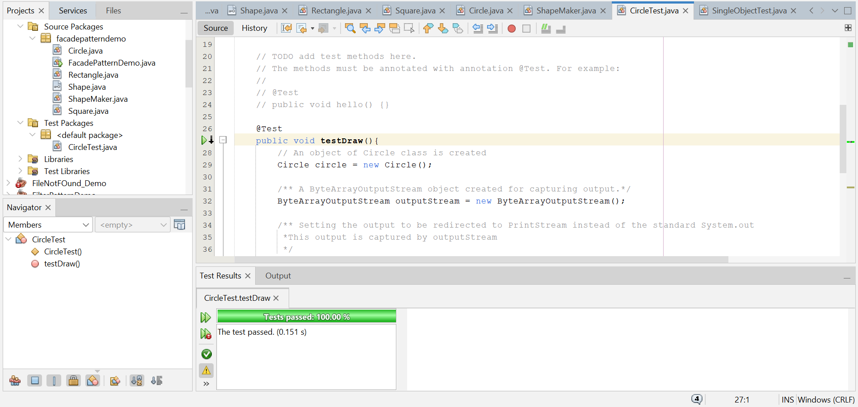

## Test Case 2:

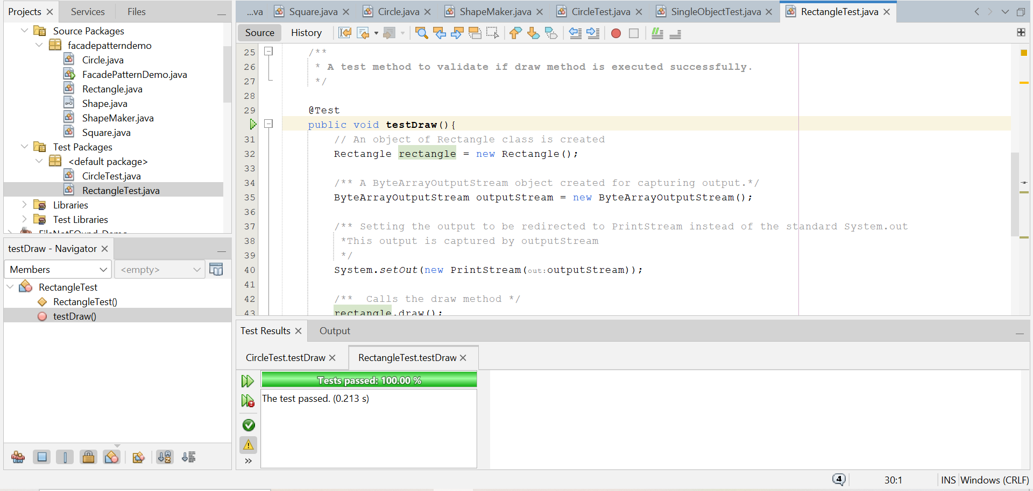

## Test Case 3:

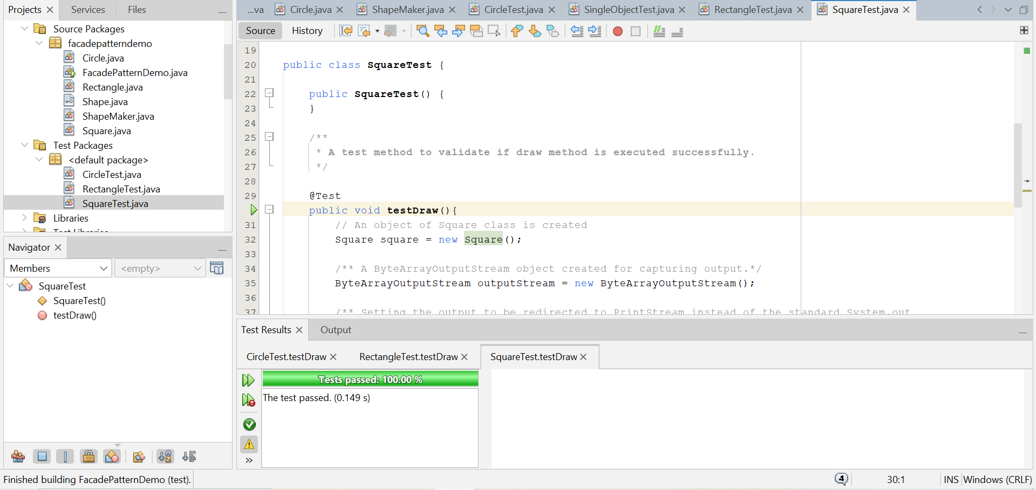

## Test Case 4:

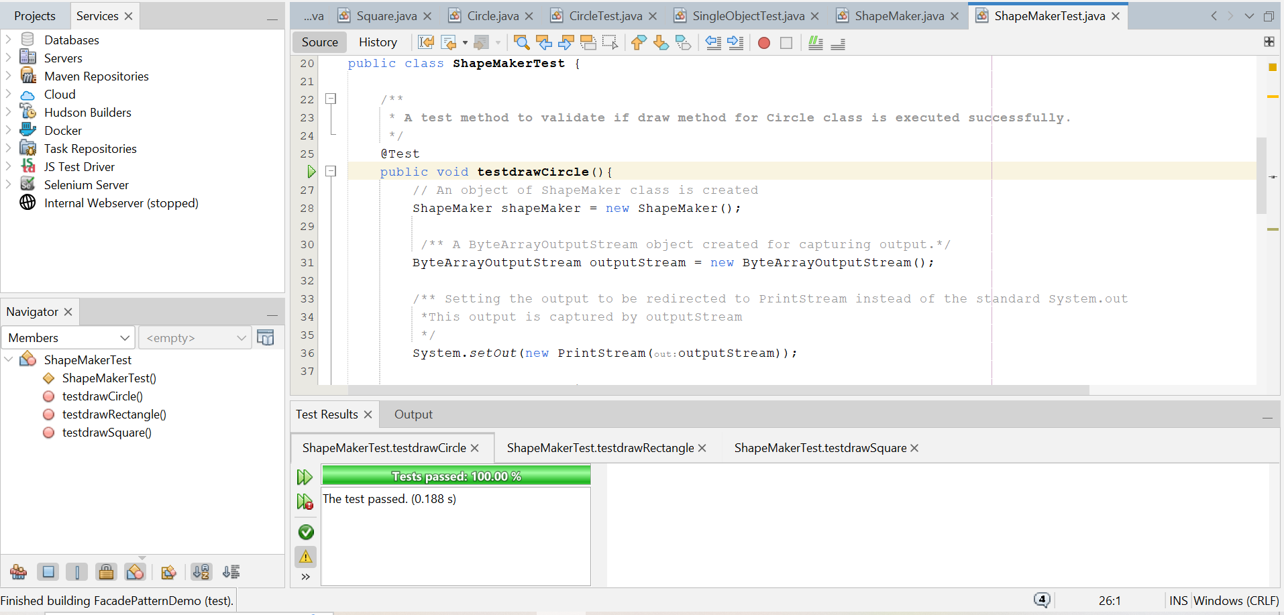

## Test Case 5:

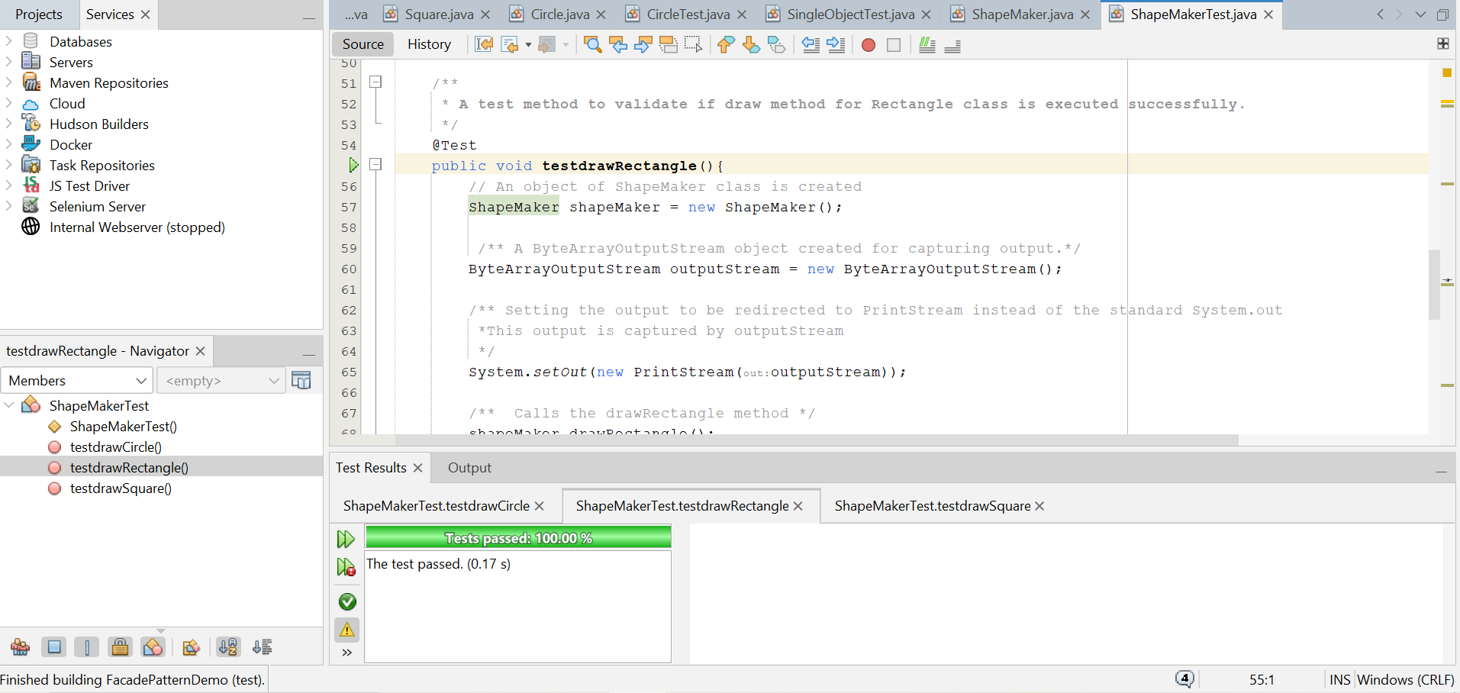

## Test Case 6:

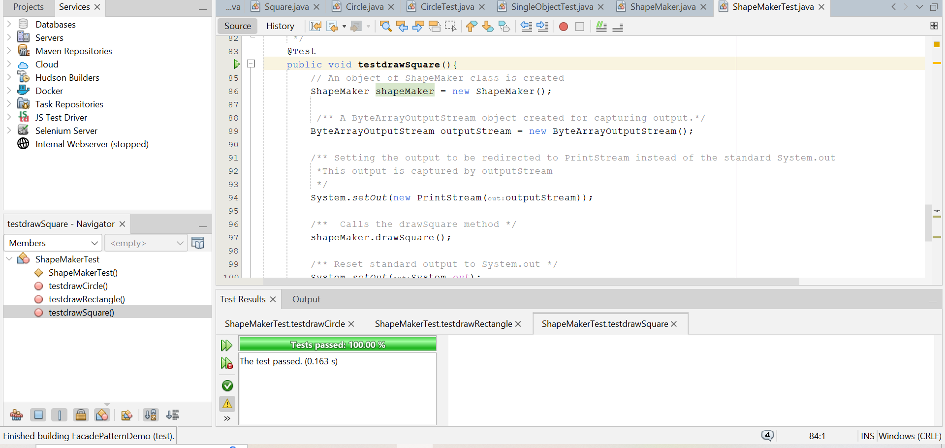

Test Case 7:  
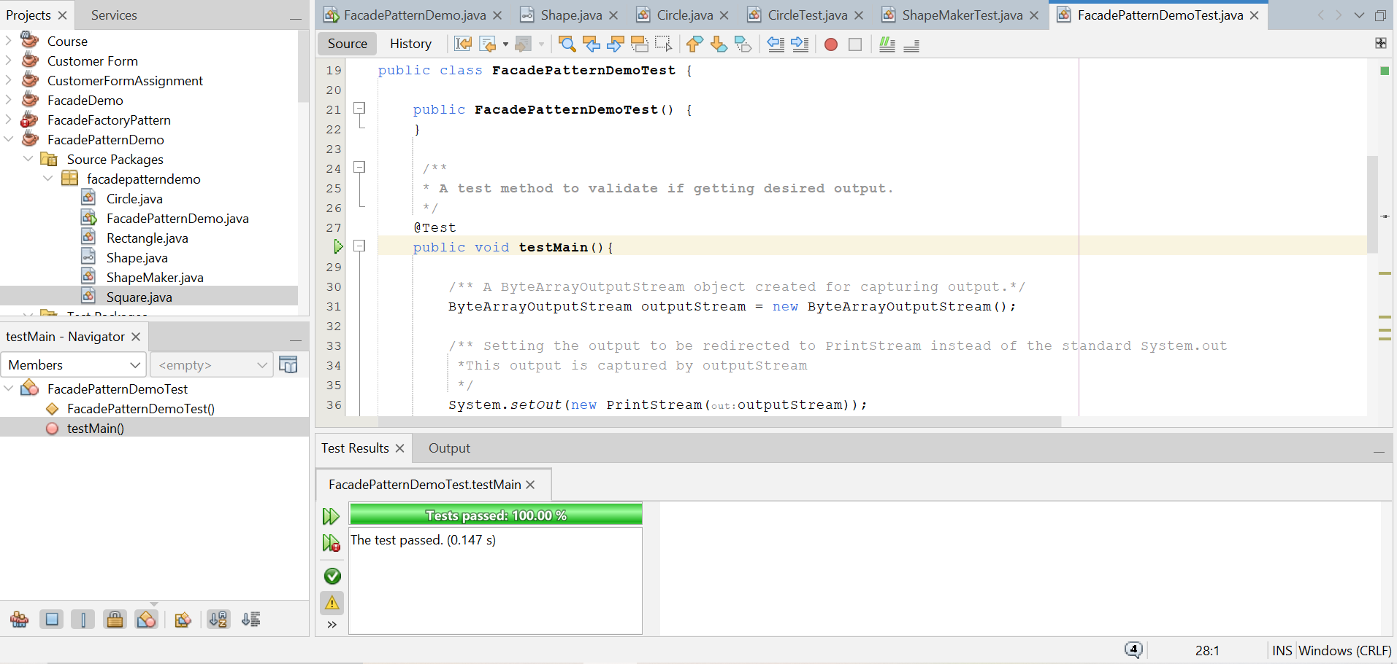

**Factory Design Pattern**

## Test Case 1:

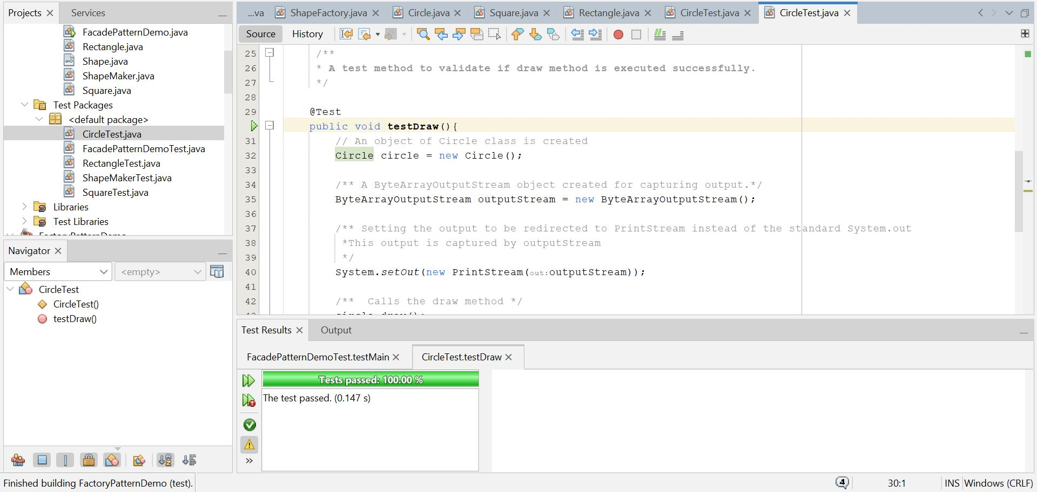

## Test Case 2:

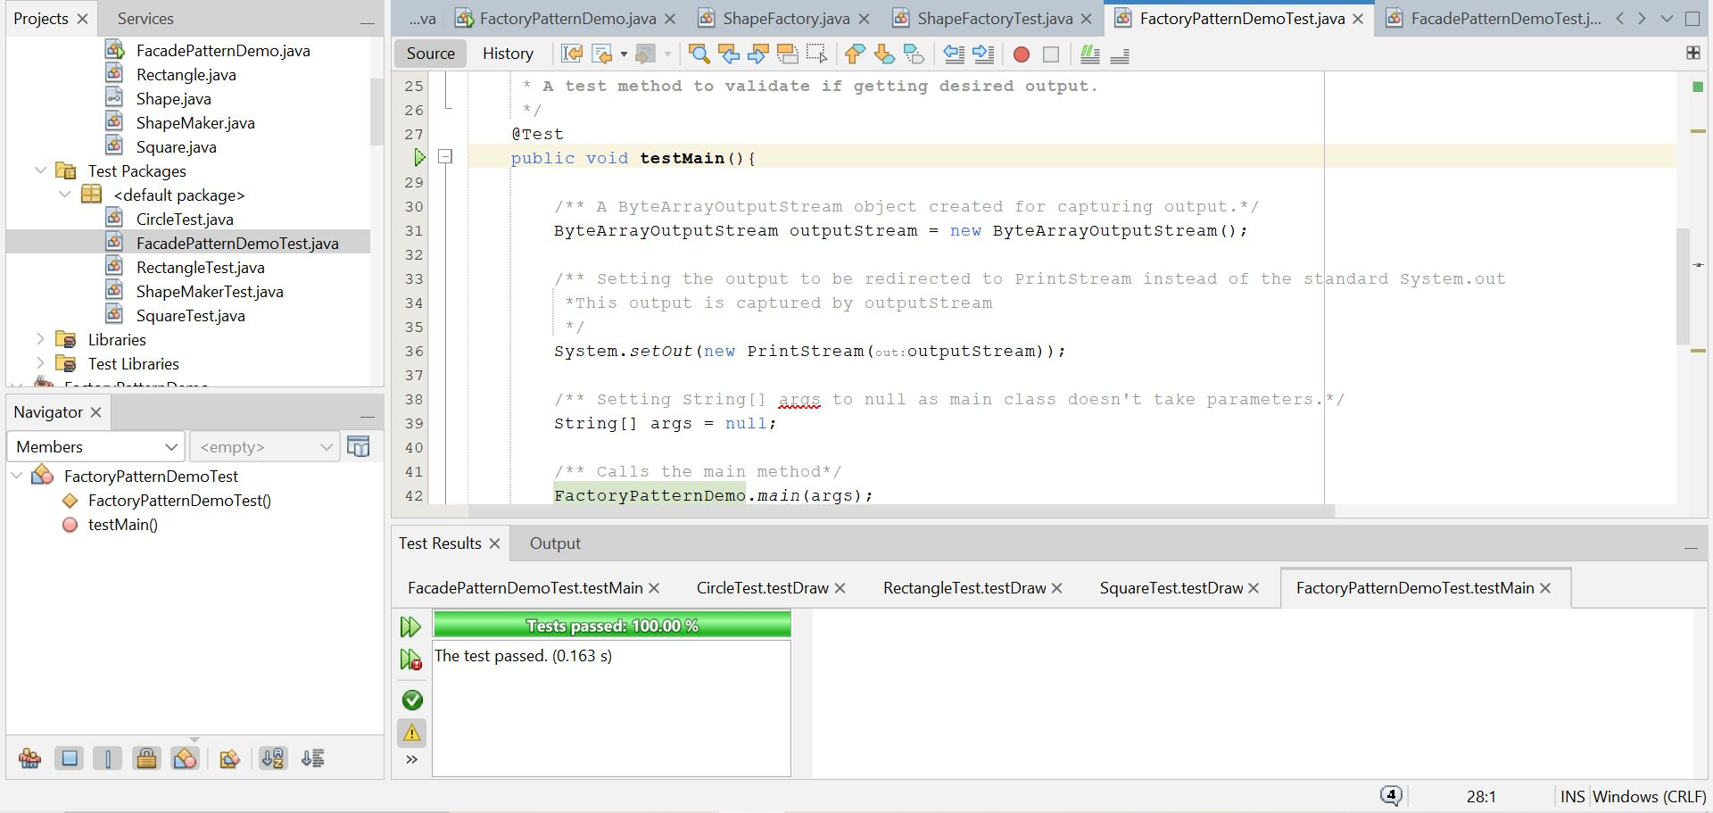

## Test Case 3:

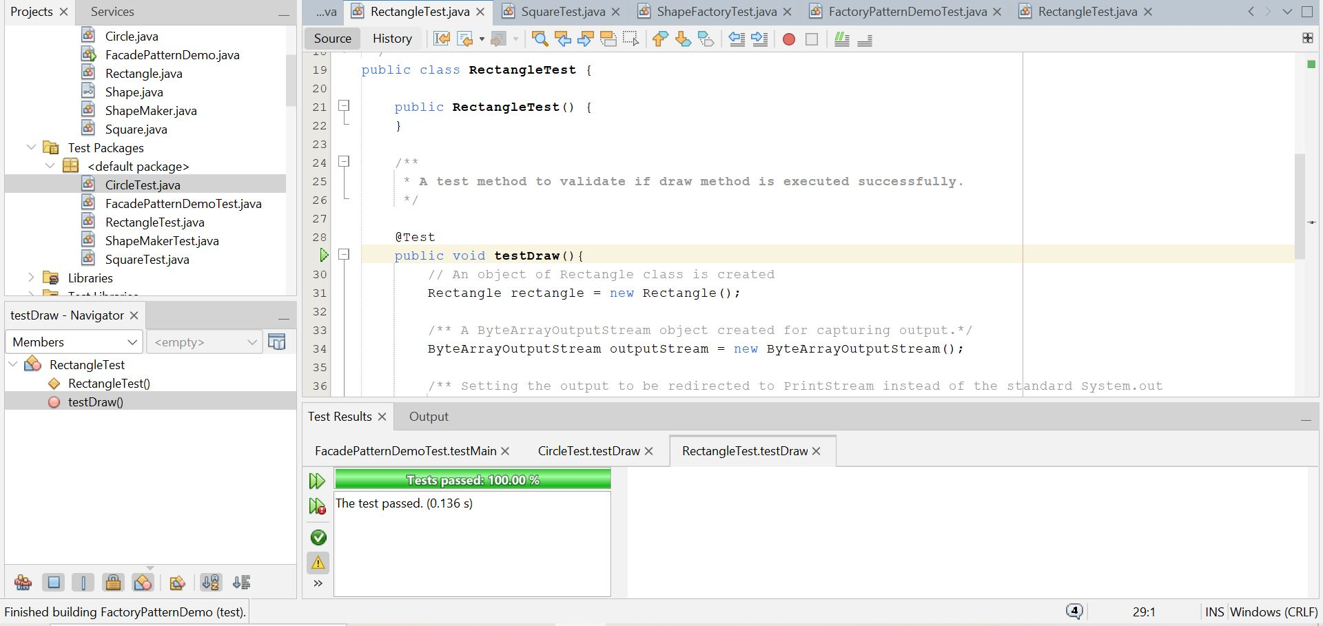

## Test Case 4:

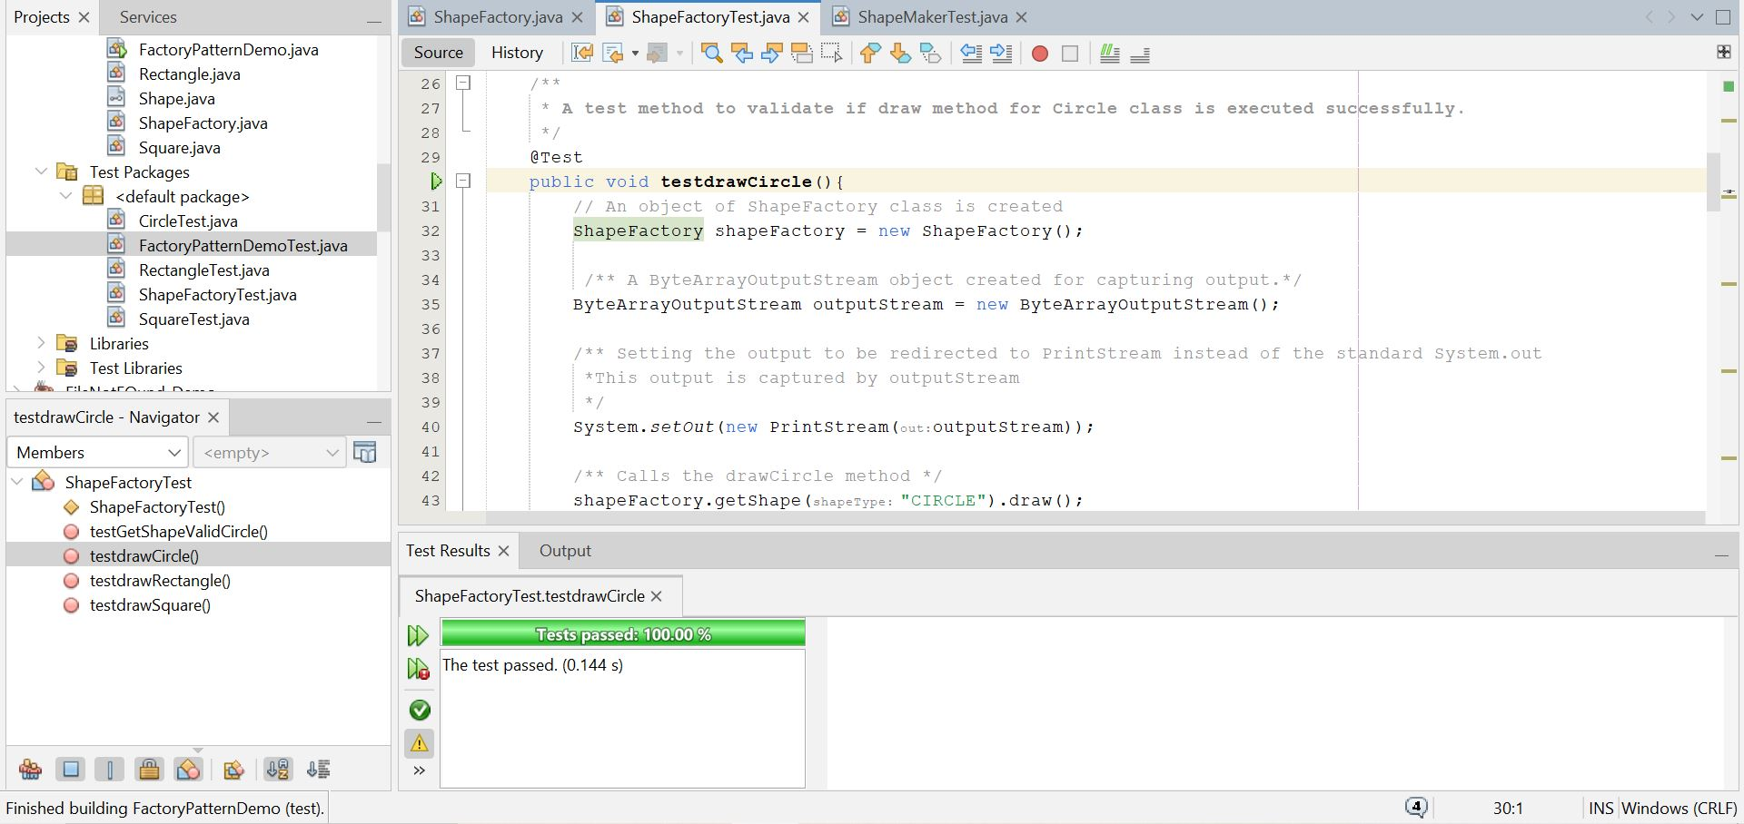

## Test Case 5:

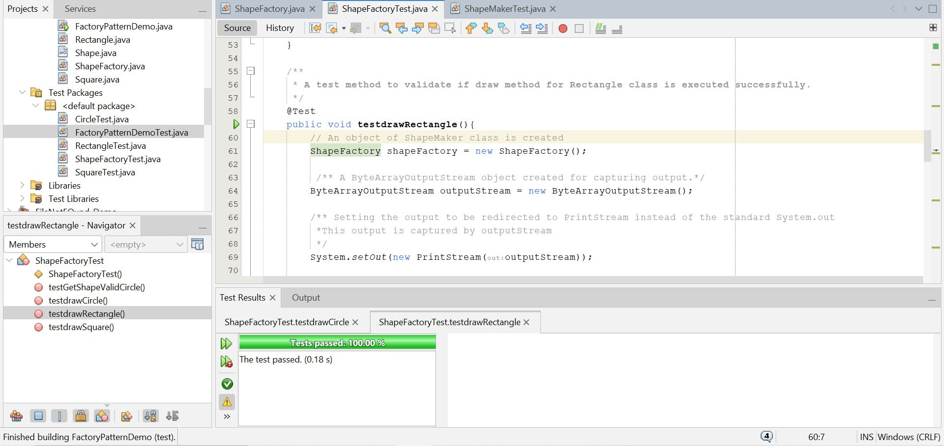

## Test Case 6:

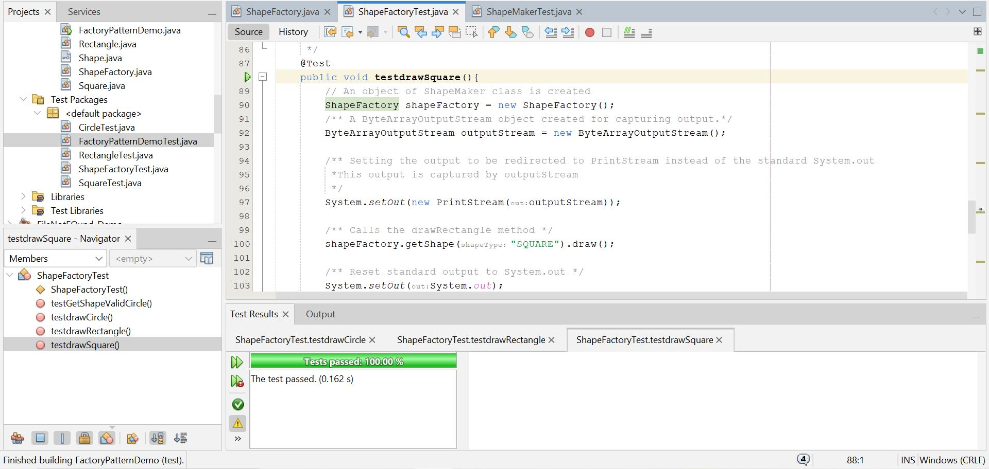

## Test Case 7:

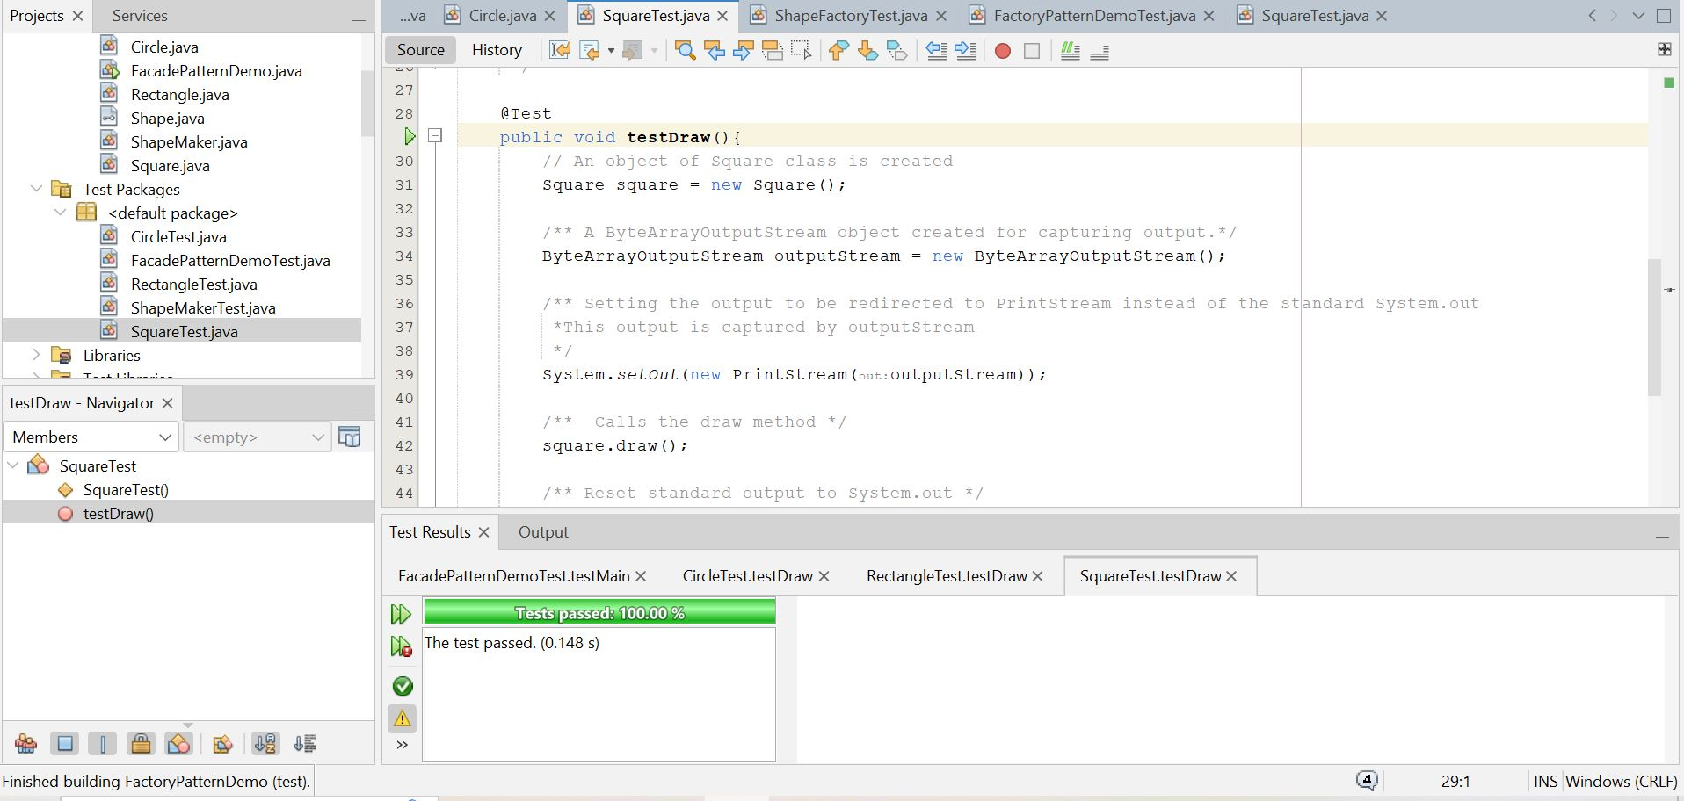

**Moon Rover State Pattern Implementation**

## Test Case 1:

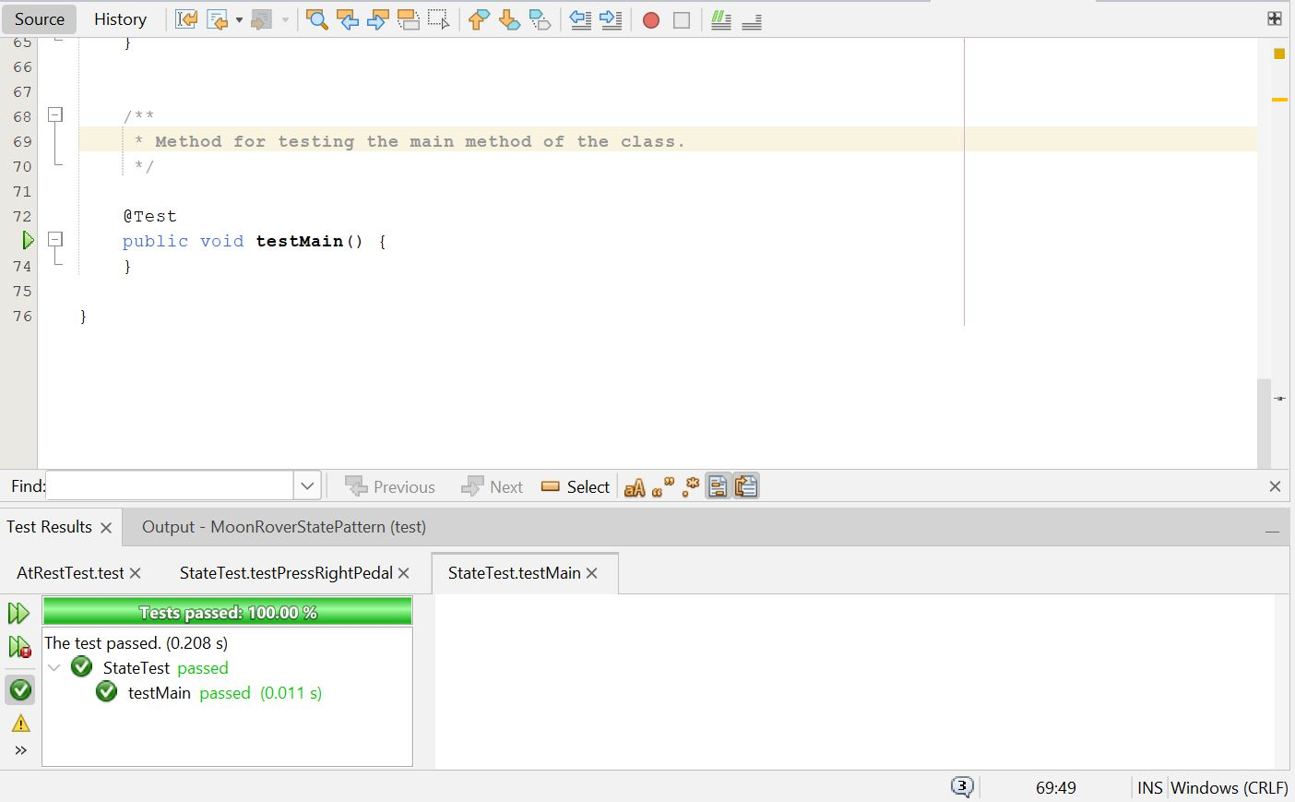

## Test Case 2:

